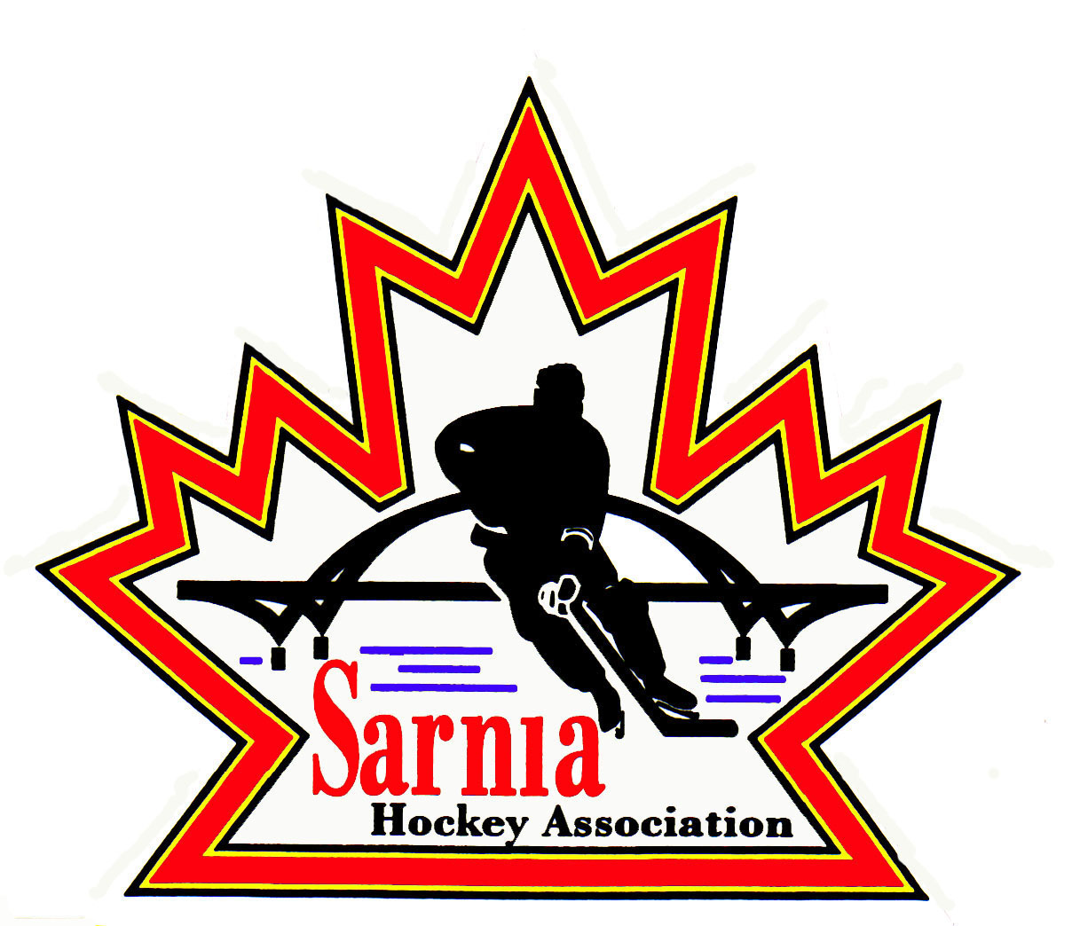

Sarnia Hockey Association

Minutes | Date: MAY 22, 2024 | time 7:00 pm

Meeting called by | Paul Walsh, President
Type of meeting | Regular
Secretary | Kelly Lane, Recording Secretary

Welcome | Paul Walsh, President and meeting Chair welcomed everyone and called the meeting to order at 7:19 pm.

ATTENDANCE | Jacquie Beasley, Emily Brown, Paul Douglass, Ian Dunn, Chuck Ewart, Jeff Fogal, Terry Gray, Kelly Lane, John Mellor, Kyle Mellor, Jeffrey Needham, David Penner, Wayne Scarrow, Lesley Smith-Taylor, Kevin Taylor, Barb Walsh, Paul Walsh  Regrets: Andrew Beasley, Jerry Bernardo, Alister Brown, Darren Chevalier, Pat Forbes, Linda Lauzon, Bonny Marcy, Don McGugan, Ted Pendle Tim Turner

ACCEPTANCE OF MINUTES | MOTION #240522-001  “That the Minutes from May 07 2024, be accepted as presented.” (J. Mellor/Scarrow)  Carried

TREASURER’S REPORT | REP TEAM ACCOUNTS:  - RBC was asked to remove signing authority for rep and select team bank accounts. We are still waiting for this process to be completed. SHA Treasurer met with the RBC bank rep last week to go over some items. Unfortunately, we can’t advance loans to teams to offset tournament registration until this occurs. Treasurer will be escalating this again with the bank.  - We are also waiting for a report from the Bank with the exact team names as some of these were changed so that when we do paperwork, we have the name that matches the system. We’ve asked the AA teams to be prioritized at this point.  - We can deposit team money and hold it until their team account is ready.  - Discussion about having teams that have paid tournament fees personally submit an expense form so they can be reimbursed until their bank account is open. This will be debited from their team and will have to be paid back. This can be documented as a separate journal entry.  - Coaches/Managers must submit a receipt on our expense form to the SHA Treasurer as per our process already in place for out-of-pocket expenses.  BUDGET:  - Draft budget has been circulated for 2024/25 season. Budget is driven by projections and submissions and is based on 1078 participants which includes 519 U7-U15, 120 Foundations and 111 U16-21 Rec players and 328 Rep players.  - Budget committee met last week.  - The budget included increased ice costs and referee costs that were based on the assumed costs that will be voted on at the Alliance AGM.  - We have added a number of lines on the financial statement such as Benevity Transfers to Teams.  - Tournament revenue was also broken out.  - Volunteer credentials such as VSC (Vulnerable Sector Checks) has its own line item.  - This budget is using a surplus of $60,000 to offset registration. Any registration over 1078 will help offset this.  - There will be no change to U6 Foundations - $350 per player.  - General registration no change at $650 for U7-U15.  - U16-21 is $450 which is a decrease of $50. Hoping this will encourage more players in that age group to participate. They only receive 1 ½ hours of ice per week.  - There is a slight increase for Rep team player assessment due to extra ice and increase in ice costs. Looking at $1,100 for U8-U15. It is a $250 increase from last season.  - U16-U18 will be $1,300 for rep assessment. Last year they paid $1000.  - This is including a U18 B/BB team if the team is formed.  - OHF assessed $250 per team this year. This was an additional expense not previously paid.  - We have worked to ensure that A/AA parents/teams are aware of the increased amounts in their budget. We have not heard any feedback yet.  - Two thirds of our members are in Recreational League and we are holding these costs the same. This is the third year in a row we held costs the same for Recreation.  MOTION #240522-002  “That the 2024/25 budget and registration fees be accepted as presented.” (E. Brown/Dunn)  Carried

BILLS TO BE PAID | MOTION #240522-003  “That the bills be paid as presented.” (Brown/L. Smith-Taylor)  Carried
  Recipient | Expense | Amount
  St. Clair Township  Bluewater Referees Association  Canada Post  Erik Olsen  Scott Jones | B/BB ice tryouts  PO Box renewal  Prep Skates  Prep Skates | $ 4,845.00  $ 553.00  $ 213.26  $1,400.00  $ 550.00

REGISTRATION DIRECTOR | - B/BB Tryouts are staggered so we are holding off opening registration until June 10.  - Rep deadline for registering will be July 10.  - Regular registration will close on July 31. Late registration will be from August 1-20 and then wait list after August 21.  - We will open A/AA fall tryouts at the same time and do a separate registration for U8, U9 and U18.  - Tryouts can’t start until the following week after Labour Day.  - Prep skates will occur right after Labour Day.  - Tryout fee of $120 will stay the same. Prep skates will be the same price as well.  MOTION #240522-004  “To open registration on set dates and leaving it open with late fees starting July 31.” (L. Smith-Taylor/E. Brown)  Carried  VULNERABLE SECTOR CHECK:  - Instructors for the prep skates will need to be in compliance with having a Vulnerable Sector Check completed. Cost of the instructor fee is covered in the prep skate fees.  - Recommendation by a number of member associations to streamline so that we can roster the business instead of individuals. Right now, for example every person at Phoenix would have to have VSC’s. The OHF would then approve these businesses. There has also been a request for sharing between Associations especially in the zones.  - VSC’s for board members also needs to be completed. Registrar will send out a link to Board Members. OHF is 3-5 days of approval and Sarnia Police has a turnaround time of approximately 12 days. T  - VSC’s will also have to be completed for our tournament volunteers. There was an understanding for the reason why this has to be done, but concerns expressed about the difficulty in getting volunteers to do this especially when we are often looking for volunteers at the last minute.

ICE DIRECTOR | - Ice Scheduler has completed the BB Tryout schedule. It had to be changed due to other sport overlaps that impacted quite a number of players. The schedule has now been posted on the SHA website.  - In June PASA 2 will have ice put back in.  - We are running tryouts in Mooretown and at PASA 2.

CLINICS DIRECTOR | D1 CLINIC:  - 5 or 6 A/AA coaches that need D1 clinic have reached out. Scott Jones has provided us a contact name of someone that could run the clinic. We have also asked Sarnia Girls Hockey if they are interested in participating as well as B/BB.  We are looking at running the clinic over the summer or in early September. Registrar is requesting the Clinic to occur prior to September 6 as this is the deadline for AA rosters.  - There is no other centre close by that is running this clinic.  - We cover the cost for our coaches, but outside Associations have to pay.  - Those coaches that need to be certified have been sent the link.

POLICY REVIEW | POLICY 2.02:  MOTION #240522-005  “Housekeeping changes to Policy 2.02 Registration, Roster and Affiliate Submission Policy and Procedures to reflect current Spring Player Evaluation and Tryout plan as presented.” (K. Taylor/ L. Smith-Taylor)  Carried  Changes Required:  - Change to dates on Appendix 2.02.A.1 – Roster Submission Procedure (Spring Tryouts)  - Tasks to be completed by the Registrar by 1 June – Change to 10 June  - Tasks to be completed by Team Staff by 30 June – Change to 10 July  - Tasks to be completed by the Registrar by 30 June – Change to 10 July  - Non-Compliance Notifications will be issued by the registrar 3 Jul – Change to 12 July  - Update Alliance Intent to Play Form 23/24 - Change to Form 24/25 on Appendix 2.02.A.1, .2 & .3  - Announce the Following Dates/Deadlines to the Membership through the website and Category VPs  - June 10 - Open Registration  - July 10 - Rep Registration Deadline  - July 31 - Registration 'Closes'  - Aug 1-20 - Late Registration  - Aug 21 and after - Waitlist Registration based on Division Availability  This is a housekeeping change to update dates.

NEW BUSINESS | ALLIANCE AGM:  MOTIONS FOR AGM: Need Board’s position on these motions.  Motion #2024-01  The ALLIANCE Hockey Officiating Program is proposing a $5.00 increase to referee payments for all game lengths U10-U18, excluding U18 AAA. The increase would be implemented over the next two seasons, with a $2.00 increase applied for the 2024-2025 season and a $3.00 increase applied for the 2025-2026 season.  Prior to the AGM, feedback needs to be provided to the Alliance that game duration needs to be consistent and include AAA. Price increases in Motion 1 and reflected in revised pricing. SHA President to reach out to Alliance Executive Director regarding this change.  MOTION #240522-006  “That SHA support Alliance Motion #2024-01” (Taylor/Mellor)  Carried  Motion # 2024-02  The ALLIANCE Hockey Officiating Program is proposing the use of the four-official system for all U15 AAA hockey including League, playdown/playoff and championship games (in addition to the divisions already utilizing the four-official system).  MOTION #240522-007  “That SHA support Alliance Motion #2024-02.” (K. Taylor/Fogal)  Carried with 4 opposed  A concern was noted that when you introduce more officials for AAA that it will pull resources away and may be difficult to fulfill our referee requirements. It depends on whether they can develop level 3 referees. Need to be 18 to be eligible for this and we lose these referees as many go off to school.  SHA President to provide feedback to Alliance that they need to put pressure on Alliance supervisors to qualify more individuals to referee these games.  Motion #2024-03  ALLIANCE Hockey is incorporated as a nonprofit corporation in Ontario and as such, has a duty to review and update governing documents to conform with the Ontario Not-for-Profit Corporations Act (ONCA) by October 18, 2024.  The ALLIANCE Hockey Board of Directors is seeking Member approval of the ONCA-compliant ALLIANCE Hockey By-laws.  MOTION #240522-008  “That SHA support Alliance Motion #2024-03” (K. Taylor/E. Brown)  Carried  Motion #2024-04  ALLIANCE Hockey is incorporated as a nonprofit corporation in Ontario and as such, has a duty to review and update governing documents to conform with the Ontario Not-for-Profit Corporations Act (ONCA) by October 18, 2024.  The ALLIANCE Hockey Board of Directors is seeking Member approval of the ALLIANCE Hockey Policies that support ALLIANCE Hockey By-law One.  MOTION #240522-009  “That SHA support Alliance Motion #2024-04” (K. Taylor/J. Needham)  Carried  NEXT MEETING:  - Next meeting is Tuesday, June 4, 2024, at 7:00 pm at Clearwater Arena Lower Hall.

adjournment | MOTION #240522-010  “That the meeting be adjourned.” ( Gray/Fogal))  Carried

Paul Walsh Kelly Lane
President Secretary

